**CERTIFICATION MANAGEMENT**

**SYSTEM**

PREPARED FOR

Salesforce Development Training Program

Capgemini Technology Service

**PREPARED BY**

Shreya Anand

**Abstract:**

The Certification Management System is a Salesforce-based solution for managing all certification requests of a company. It accepts certification requests from employees and sends it to the app admin to process the request. The application allows the app users to raise new certification requests within the set guidelines of the company, assign any available vouchers, send approval request to the app admin, update the final result of the certification. All the certification, voucher, and employee details can be viewed, added and modified on this Salesforce application.

**Scopes:**

**In the scope:**

Following is the functionality provided by the system:

There are two categories of people who would access the system: App Admin and App User. Each of these would have some exclusive privileges.

1. The App User can:

a. View all employee details.

b. View all certification details available.

c. View all voucher details and if they are active or not.

d. Raise certification requests for employees and modify them.

e. Update the status of approved certification to the final result (passed/failed).

2. The App admin can:

a. Add, edit and track certification details.

b. Add, edit and track voucher details.

c. View the employee details.

d. Approve or reject the certification requests for employees.

**Out of the scope:**

The following functionalities have not been covered under the application:

1. The application does not cover the calculation of certification cost and voucher discount.

2. The process of email sent by employees to the App User in mail is not included.

3. No log of payments are included.

CLASS DIAGRAM

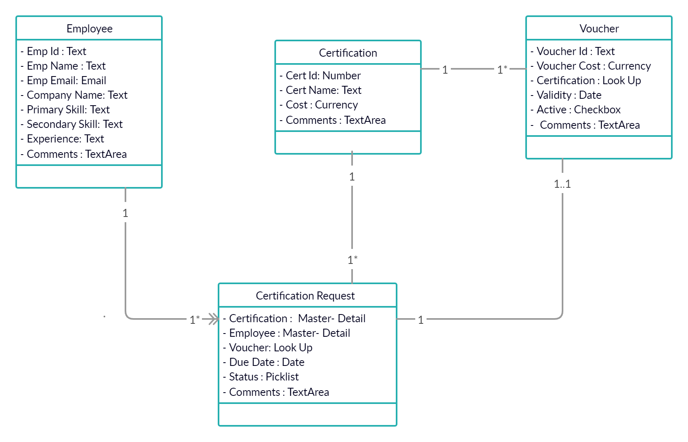 SEQUENCE DIAGRAM FOR APP USER

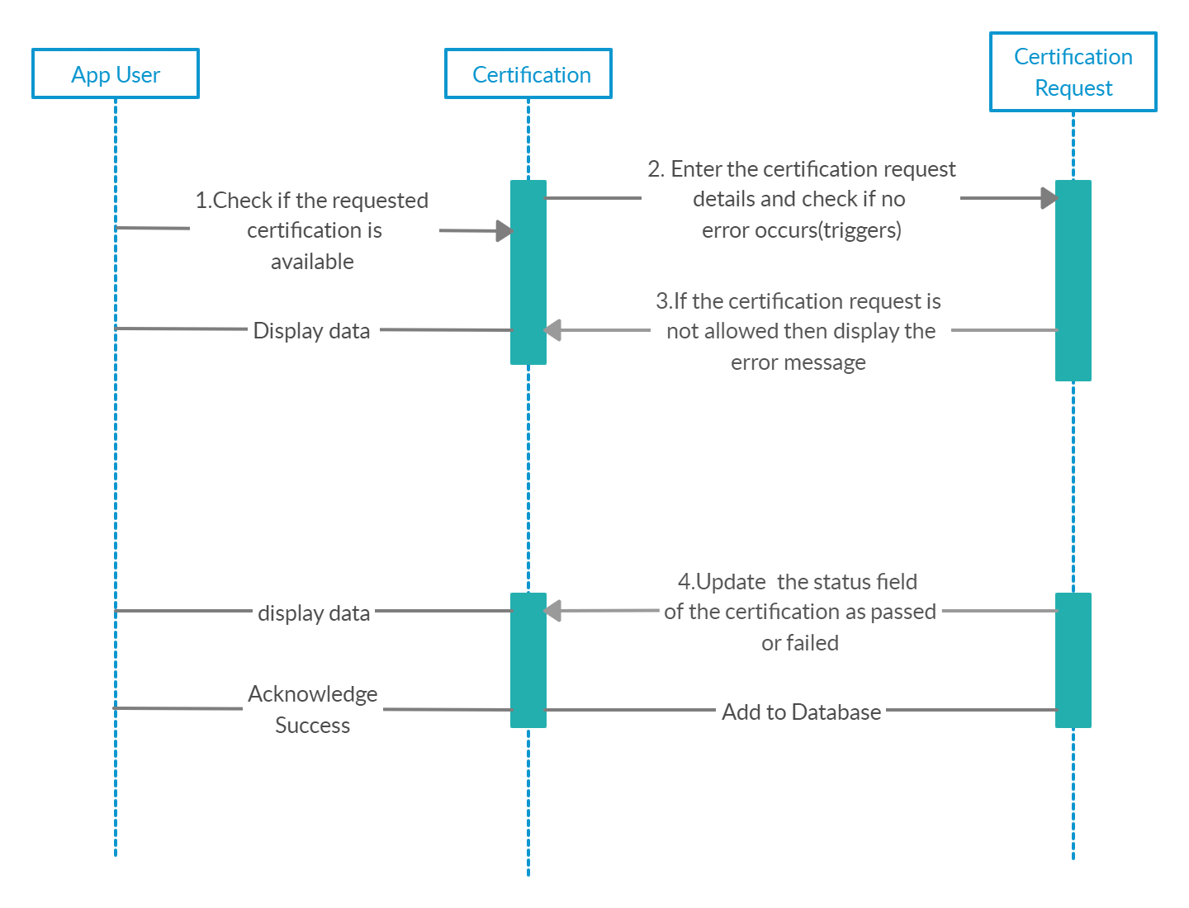

SEQUENCE DIAGRAM FOR APP ADMIN

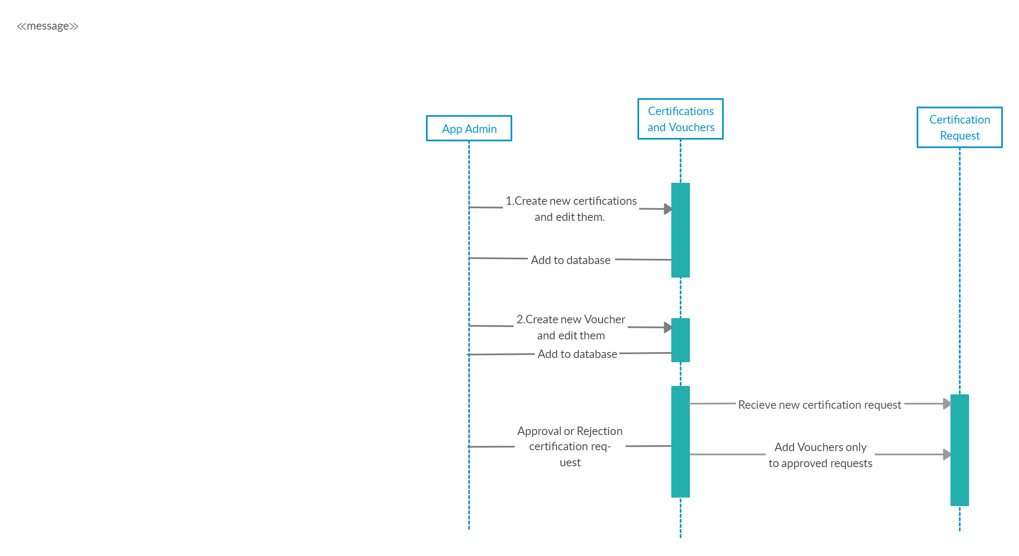

ACTIVITY DIAGRAM FOR APP USER

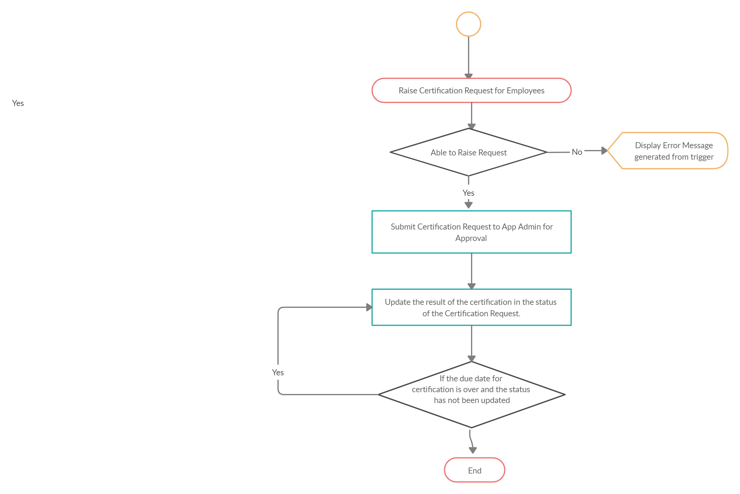

ACTIVITY DIAGRAM FOR APP ADMIN

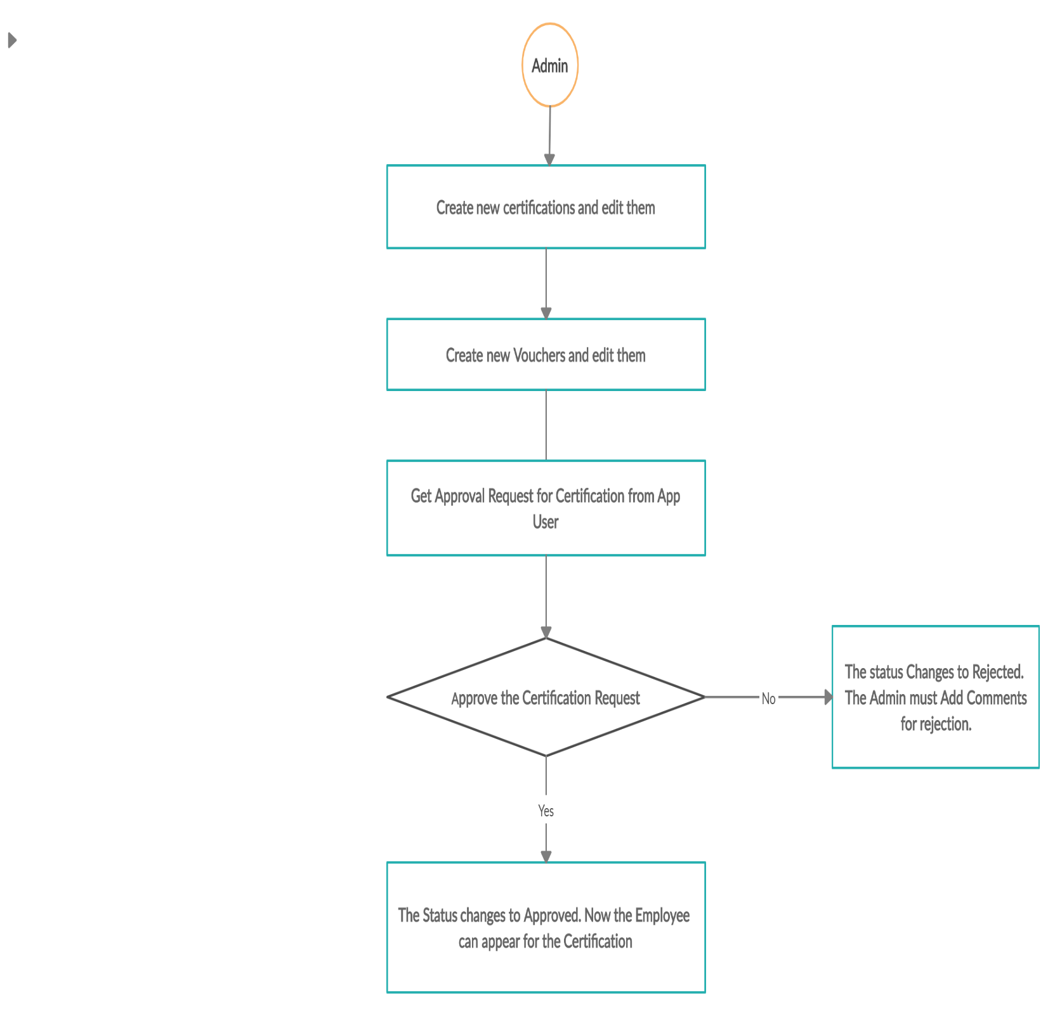

USE CASE DIAGRAM

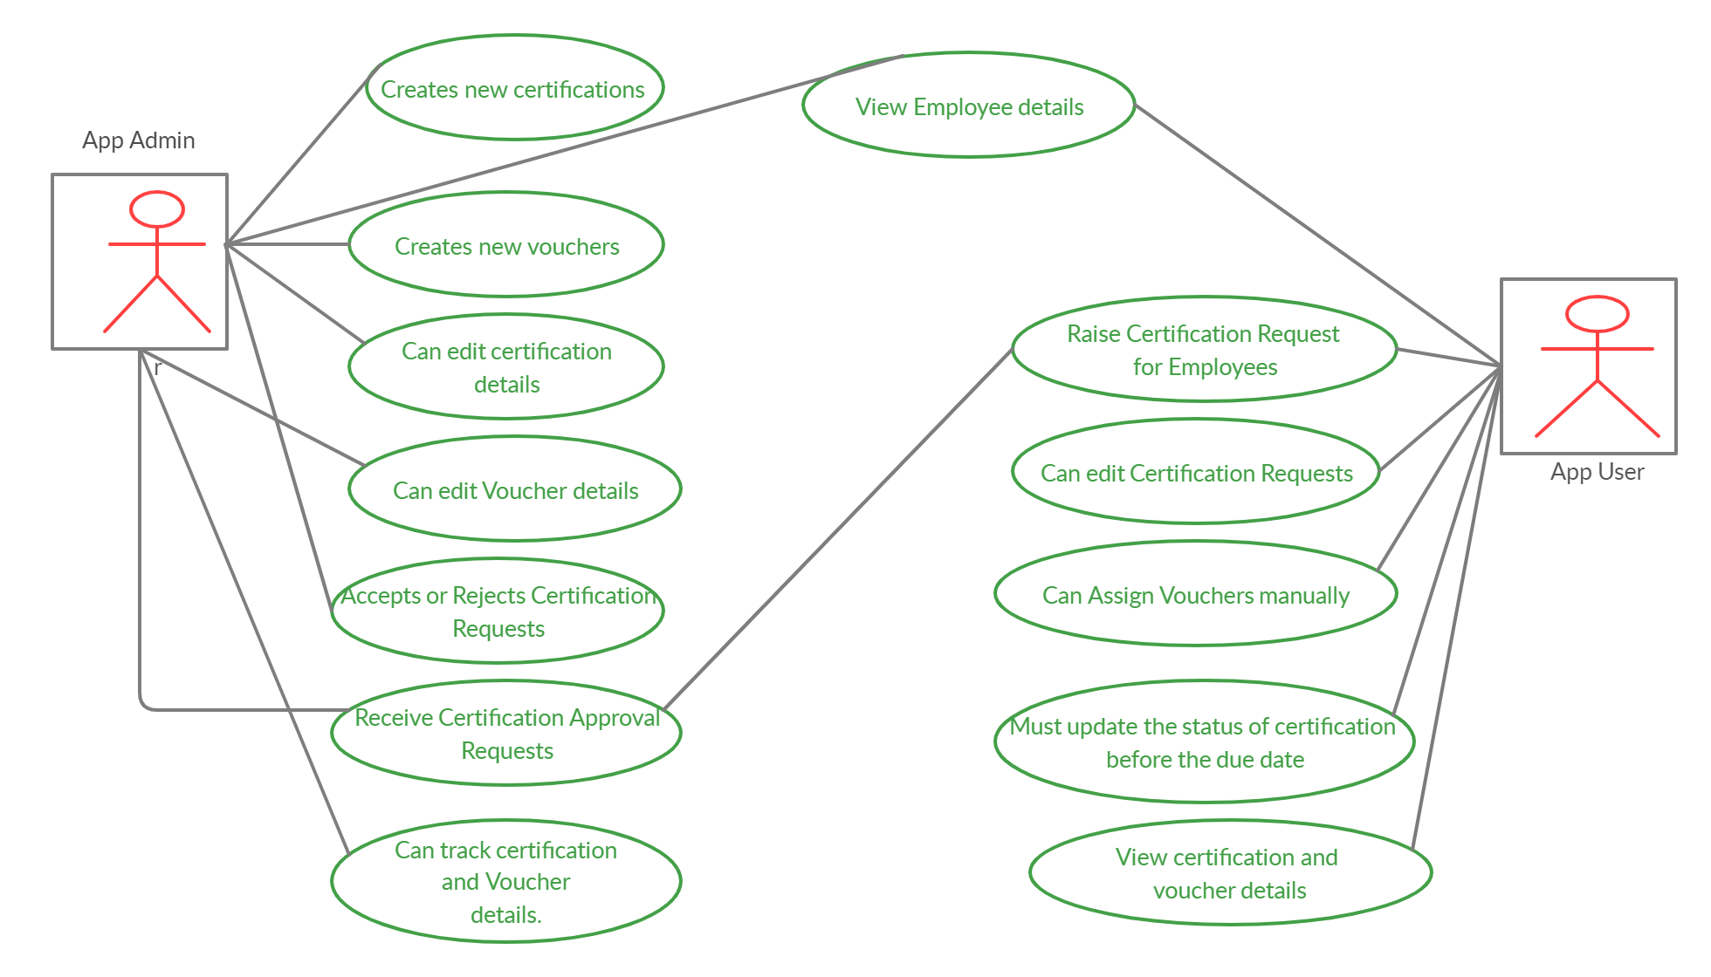

ENTITY RELATIONSHIP DIAGRAM

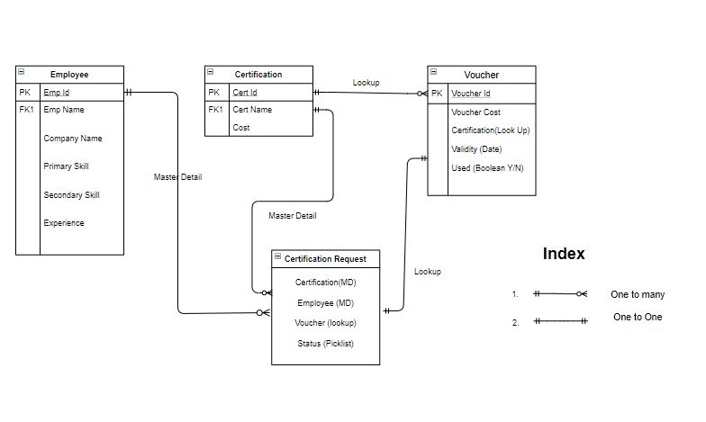

**OVERVIEW**

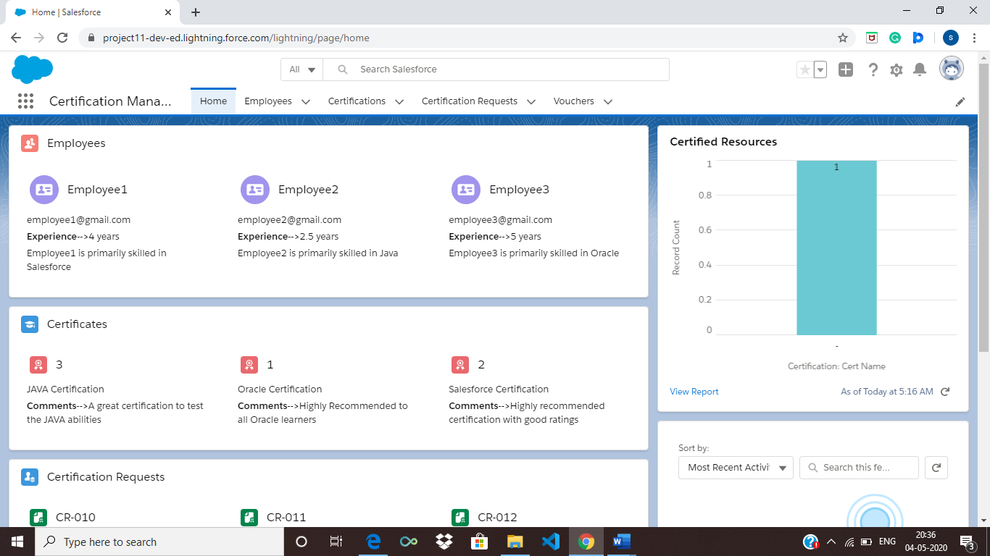

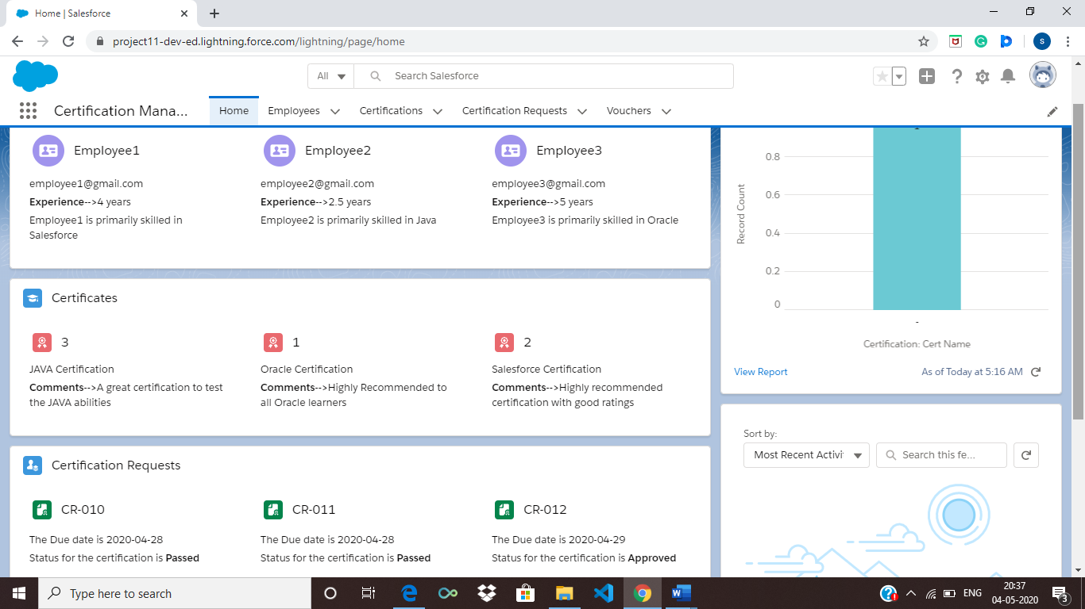

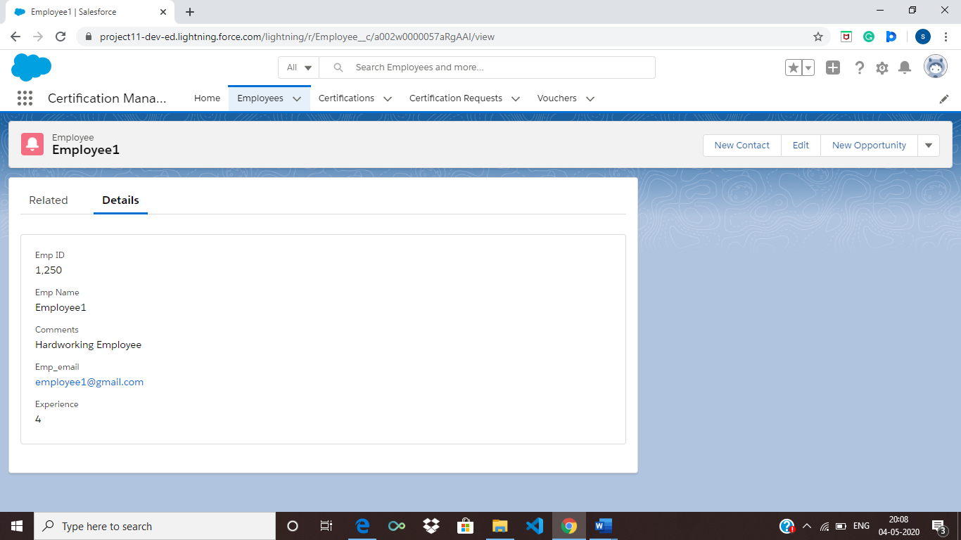

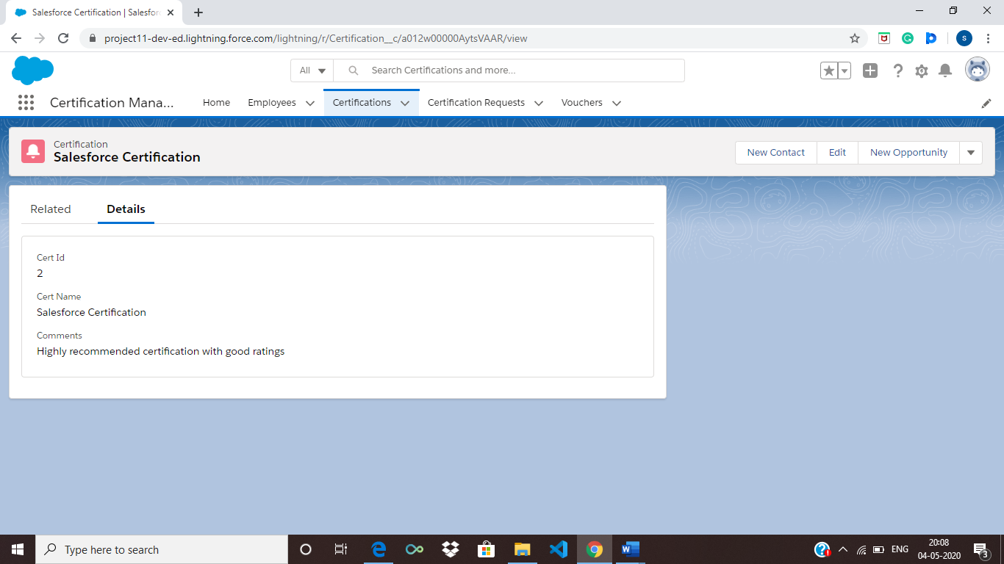

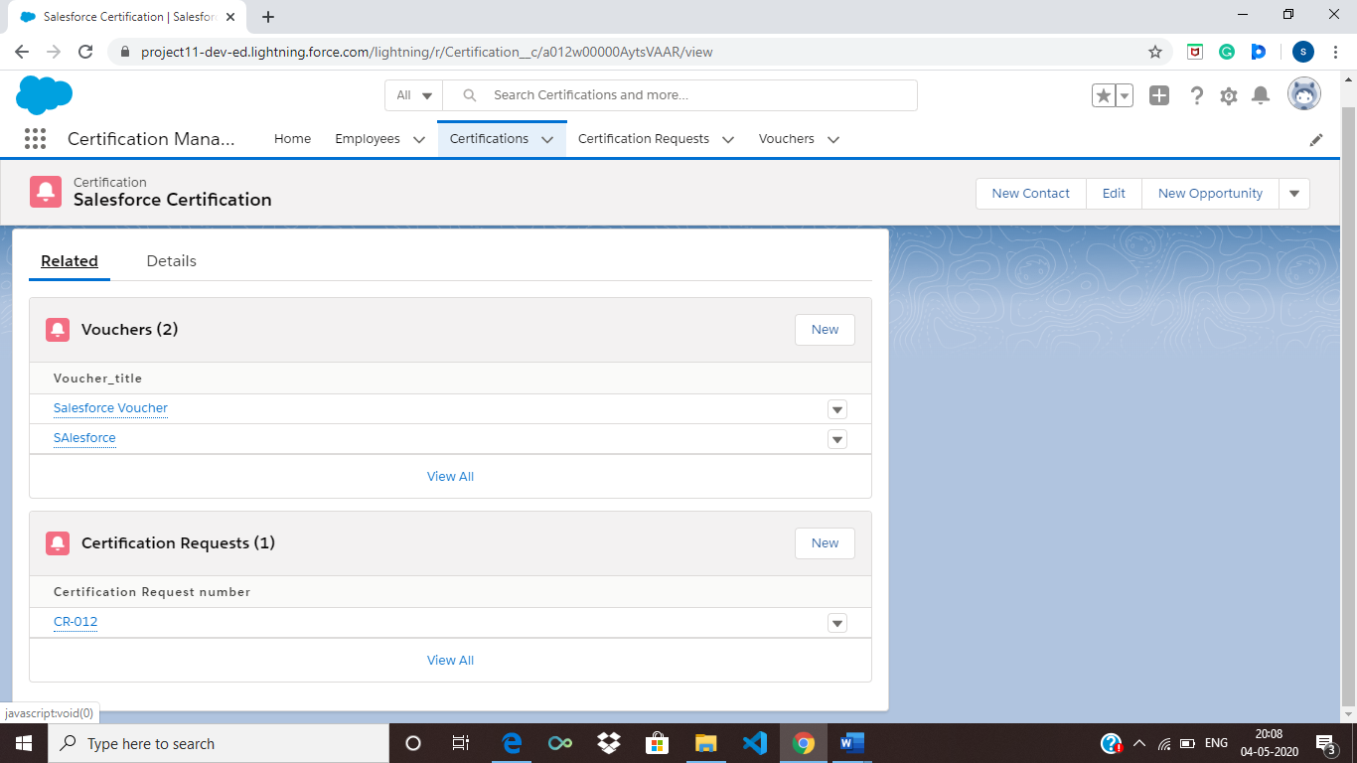

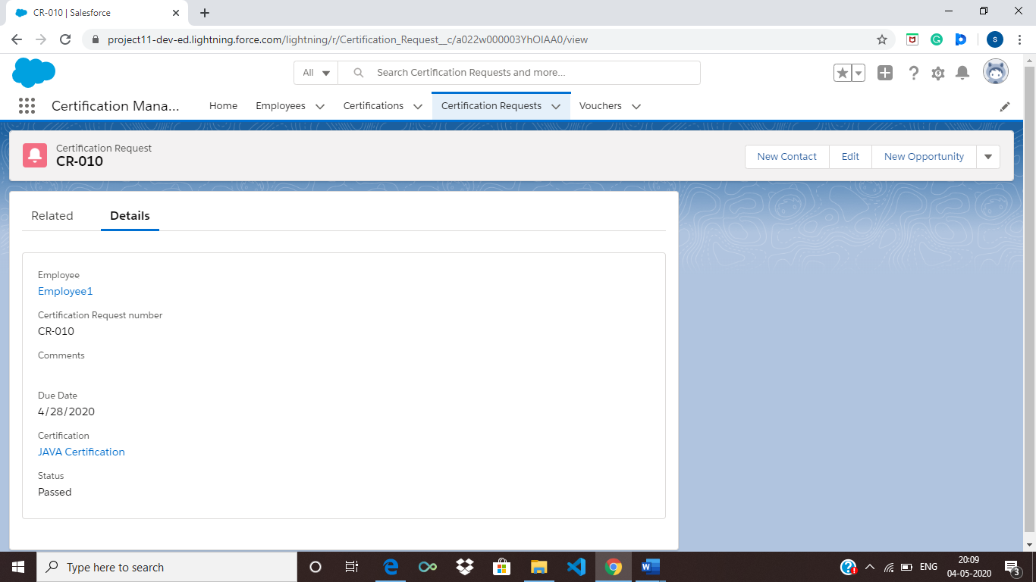

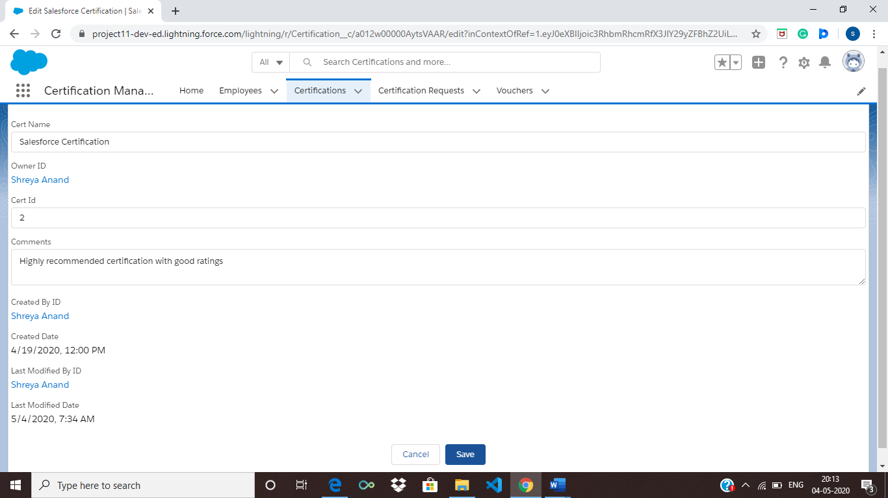

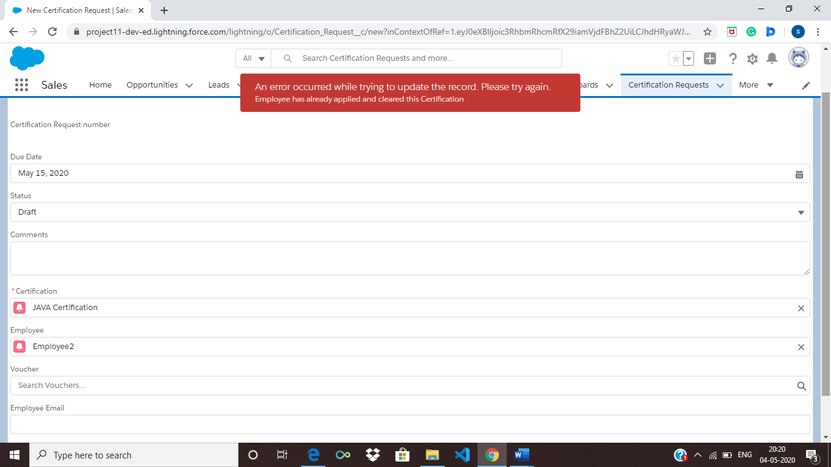

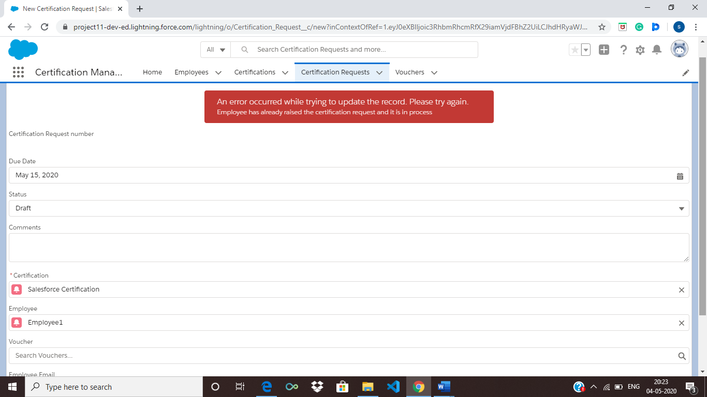

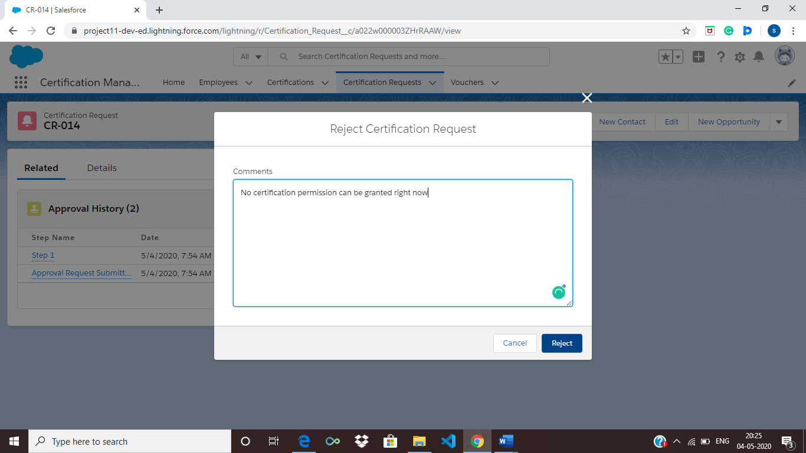 **COMPONENTS AND DETAILS**

**Object Description:**

1. **Employee**: The employee object has all data related to the employees of the company. It can be viewed by both the App user and the App Admin.

Attributes​:

  Emp ID – Text

Emp_email- Email (mandatory)

Emp Name- Text

Primary Skill- Text

Secondary Skill- Text

Experience- Number

Comments- TextArea

1. **Certification:** The certification object has all data related to available certifications that the company has. It is created by the App Admin and can be viewed by App User.

Attributes:

Cert Id- Number

Cert Name- Text

Comments- TextArea

Cost- Currency

1. **Certification Request**: The certification request object has all data related to requests made by the App User on behalf of the Employees. It can be raised by App User only but can be Approved by App Admin only.

Attributes:

Certification- Master Detail Relationship

Employee- Lookup Relationship

Voucher- Lookup Relationship

Due Date- Date

Comments- TextArea

Employee email- Email (hidden field)

Status- Picklist

Options :

* Draft (Default)
* Approved
* Rejected
* Passed
* Failed
* Assigned

4. **Voucher**: The voucher object has all data related to vouchers available for the different certifications. It can be created by App admin only but can be viewed and assigned by the App User also.

Attributes:

Voucher Id- Text

Voucher Cost- Currency

Certification- Lookup Relationship

Validity- Date

Active- Checkbox

Comments- TextArea

**Process involved:**

Process Name- **Process for Certification**

This process is used to automate approval request submission once a certification request is made. It also changes the status field of the request once the App Admin approves or rejects the certificate request.

**Approval Process**

Approval Process Name- **Certification approval**

This process is to raise approval request for Certification when the certification request record is created by the App User and it automatically gets assigned to the queue of App Admins. It also provides email notification to the Employee and the App User once the request is submitted and also when it is either approved or rejected.

**Workflow**

Workflow Name- **To_get_employee_email**

To get Employee email id in the Certification request object from the Employee object so that notification can be sent to the Employee regarding his certification request.

**Trigger**

Two triggers are made on two different objects:

**ConditionCheck**- This trigger is made on Certificate Request object. It is a before insert and before update trigger to ensure that:

1. App User should not be able to raise same certification voucher request again if one already exist in the system
2. App User should not be able to add new certification voucher request in system if there is any pending request exist for that employee.
3. If an employee gets passed/failed in any certification then system should not allow to App User to raise same certification request for that employee again.
4. An active Voucher should be assigned automatically to the Certification Request once it is approved
5. Certification request status should be automatically changed to Assigned once voucher is assigned to the certification request

**VoucherConditionCheck**- This trigger is made on Voucher object. It is an after insert and before update trigger to ensure that:

1. System should be automatically assigning vouches to existing approved certification request, when new vouches are added in system to fulfill first come first serve order.
2. Only Unused voucher should be assigned to the certification request. App Admin should not able to assign voucher manually without approval.
3. Only One Voucher can be assigned to 1 Certification request.

**Email Alerts:**

Three email alerts have been used:

Description1- **Approval has been accepted**

This alert is used when approval request has been accepted by the App Admin to notify the App User and the Employee.

Description2- **Approval has been rejected**

This alert is used when approval request has been rejected by the App Admin to notify the App User and the Employee.

Description 3- **Email alert for approval submission**

This alert is used when approval request has been submitted by the App User to notify the Employee.